**####**

Pharmacy Management System

**Interim Report**

**ICT2233 - Software Engineering**

**Submitted by:**

1. TG/2020/674 – Chandimal Priyamantha
2. TG/2020/707 – K.G.L.Nethsara Kiringoda
3. TG/2020/694 – H.A.R.N.Karunarathna
4. TG/2020/706 – K.G.S. Dissanayake
5. TG/2020/684 – M.A.D.A.M.Arachchi
6. TG/2020/747 – H.Tirasha Dinuki
7. TG/2020/676 – A.Asama
8. TG/2020/704 – T.Madusha

**Lecturer in charge:** Miss. Chanduni Gamage

**Submission Date:** 2023/09/29



Bachelor of Information and Communication Technology.

Department of Information and Communication Technology.

Faculty of Technology.

University of Ruhuna.

**Declaration**

“We certify that this project does not incorporate without acknowledgment, any material previously submitted for an assignment in any institution, and to the best of my knowledge and belief, it does not contain any material previously published or written by another person or myself except where due reference is made in the text. I also hereby give consent for my dissertation, if accepted, to be made available for photocopying and for interlibrary loans, and for the title and summary to be made available to outside organizations”.

Name Index No Signature

1. Chandimal Priyamantha TG/2020/674 …………………………
2. K.G.L.Nethsara Kiringoda TG/2020/707 …………………………
3. H.A.R.N.Karunarathna TG/2020/694 …………………………
4. K.G.S. Dissanayake TG/2020/706 …………………………
5. M.A.D.A.M.Arachchi TG/2020/684 …………………………
6. H.Tirasha Dinuki TG/2020/747 …………………………
7. A.Asama TG/2020/676 …………………………
8. T.Madusha TG/2020/704 …………………………

**Acknowledgement**

We would like to express our gratitude to all those who have contributed to the successful completion of this endeavor. Their unwavering support, guidance, and encouragement have been invaluable throughout this journey.

First and foremost, we extend our deepest appreciation to our head of the department for their guidance and constant supervision of Ms. Chanduni Gamage, whose expertise, patience, and dedication have been instrumental in shaping this project.

We wish to extend our thanks to all colleagues and friends who have been a constant source of motivation and camaraderie. Your discussions, brainstorming sessions, and moral support have been integral to this undertaking.

Table of Contents

**Chapter 1: Introduction**

1.1 Statement of the Problem

1.2 Aims and Objectives

1.3 Scope of the Project

1.4 Gantt Chart

**Chapter 2: System Analysis & Design**

2.1 Use case Diagram

2.2 Use case narratives

2.3 Activity Diagrams

2.4 Sequence Diagrams

2.5 ER diagram

2.6 Software Requirement Specification

**Chapter 3: Proposed System Design**

3.1 Architecture Design

3.2 Proposed System Interfaces

3.3 Report Designs

3.4 Test plan for the system

3.5 Proposed Software Engineering Methodology

**Conclusion**

**References**

**List of figures**

Figure 1 - Gantt Chart 10

Figure 2 – Use case diagram 12

Figure 3 – Log In Activity Diagram 13

Figure 4- Add information Activity Diagram 14

Figure 5 – Delete Information Activity Diagram 15

Figure 6 – Direct Customer Management Activity Diagram 16

Figure 7 – Formal Communication Activity Diagram 17

Figure 8 – Medicine Management Activity Diagram 18

Figure 9 – Remote Payment Activity Diagram 19

Figure 10 - Remote Order Activity Diagram 20

Figure 11 – Reset Password Activity Diagram 21

Figure 12 – Update Information Activity Diagram 22

Figure 13 – User Management Activity Diagram 23

Figure 14 Log Out Activity Diagram 24

Figure 15 – Log In Sequence Diagram 25

Figure 16 - Manage Customer Sequence Diagram 26

Figure 17 – Medicine Management Sequence Diagram 27

Figure 18 - Inventory Management Sequence Diagram 28

Figure 19 – Report generating Sequence Diagram 29

Figure 20 – Remote Order Sequence Diagram 30

Figure 21 – Remote payment Sequence Diagram 31

Figure 22 – ER Diagram 32

Figure 23 - Architectural Design 35

Figure 24 - Dashboard 36

Figure 25 - Direct Customer Order Interface 37

Figure 26 - Remote Customer Order Interface 37

Figure 27 - Remote Customer Payment Interface 38

Figure 28 - Email Interface 39

**Chapter 1: Introduction**

We propose to design and build a thorough pharmacy shop management application that will streamline business processes and ensure effective staff management, customer engagement, medication inventory control, precise financial tracking, formal communication facilities (email), remote medication distribution, and strong reporting capabilities. The app will target both small and large pharmacies and be user-friendly and accessible.

* 1. **Statement of the problem**

Due to manual processes, many small- and medium-sized pharmacies find it difficult to operate their business effectively, which causes mistakes in the management of inventory, customers, and finances.

Inefficiencies and significant revenue losses result from the lack of a centralized system for managing the inventory of medicines, customer information, and employee data.

* 1. **Aims and Objectives**

The project's goal is to provide a user-friendly, effective Pharmacy Shop Management Application that improves the workflow of pharmacy operations as a whole. The precise goals consist of:

1. Managing personnel Information: Create a module that makes it simple to handle personnel details such identities, responsibilities, and schedules.

2. Managing Customers: Create a customer management module that simplifies order history, communication, and customer registration.

3. Managing Medicine: Develop a module to check stock levels, expiration dates, and enable reordering alerts for medicines.

4. Managing Financials: Create a module for accounting and invoicing so that revenues, expenses, and client bills can all be tracked accurately.

5. Reporting: Create a reporting module that offers details on sales patterns, inventory turnover, profit margins, and other important performance metrics.

6. Formal Communication: Create a module that enables communication with clients and vendors.

7. Remote pharmaceutical Distribution: Create a pharmaceutical distribution module that offers consumers precise and efficient service.

* 1. **Scope of project**

1.Planning the project (Week 1):

- Specify the project's goals, objectives, and needs.

- Divide up team members' roles and tasks.

- Create lines of communication to facilitate productive teamwork.

|  |  |  |  |
| --- | --- | --- | --- |
| **Task** | **Duration (Days)** | **Start** | **End** |
| Planning the project | 07 | 19/08/2023 | 25/08/2023 |

2.Designing UI/UX (Week 2):

- Produce mockups and wireframes for the user interface of the program.

- Collect suggestions and improve the design for the best user experience.

|  |  |  |  |
| --- | --- | --- | --- |
| **Task** | **Duration (Days)** | **Start** | **End** |
| Designing UI | 07 | 26/08/2023 | 31/08/2023 |

3. Database design (Week 3):

- Create a database schema to contain information about the personnel, customers, medications, and finances.

- Ensure scalability and data integrity.

|  |  |  |  |
| --- | --- | --- | --- |
| **Task** | **Duration (Days)** | **Start** | **End** |
| Database Design | 07 | 26/08/2023 | 31/08/2023 |

4.Development on the front end (Week 4):

- Create user interfaces for different modules utilizing cutting-edge JavaFX technologies.

Develop a responsive design strategy.

|  |  |  |  |
| --- | --- | --- | --- |
| **Task** | **Duration (Days)** | **Start** | **End** |
| Development on the front end | 07 | 01/09/2023 | 07/09/2023 |

5.Development on the back end (Week 5):

- Create the essential logic and features of the program.

- Connect the front end to the back-end services and database.

|  |  |  |  |
| --- | --- | --- | --- |
| **Task** | **Duration (Days)** | **Start** | **End** |
| Development on the back end | 07 | 08/09/2023 | 14/09/2023 |

6. Quality assurance and testing (Week 6):

- Carry out exhaustive testing to find and address any flaws or problems.

- Ensure system stability and data security.

|  |  |  |  |
| --- | --- | --- | --- |
| **Task** | **Duration (Days)** | **Start** | **End** |
| Quality assurance and testing | 07 | 15/09/2023 | 21/09/2023 |

7.Documentation (Week 7):

- Produce thorough documentation for installation, upkeep, and user instructions.

|  |  |  |  |
| --- | --- | --- | --- |
| **Task** | **Duration (Days)** | **Start** | **End** |
| Documentation | 01 | 22/09/2023 | 29/09/2023 |

8.Deployment and Training (Week 8):

- Install the application on a client machine or hosting platform.

- Teach pharmacy personnel how to use the system efficiently.

|  |  |  |  |
| --- | --- | --- | --- |
| **Task** | **Duration (Days)** | **Start** | **End** |
| Select a client | 07 | 30/09/3023 | 06/10/2023 |

9.Finalisation and Presentation (Week 9):

- Check the application one last time to make sure all requirements have been completed.

- Create a presentation that highlights the features and functionality of the program.

|  |  |  |  |
| --- | --- | --- | --- |
| **Task** | **Duration (Days)** | **Start** | **End** |
| Select a client | 07 | 07/10/2023 | 13/10/2023 |

* 1. **Gantt Chart**

Figure - Gantt Chart

**Chapter 2: System Analysis and Design**

**2.1 Use case diagram**

Figure – Use case diagram

**2.2 Use case narratives**

**2.3 Activity diagrams**

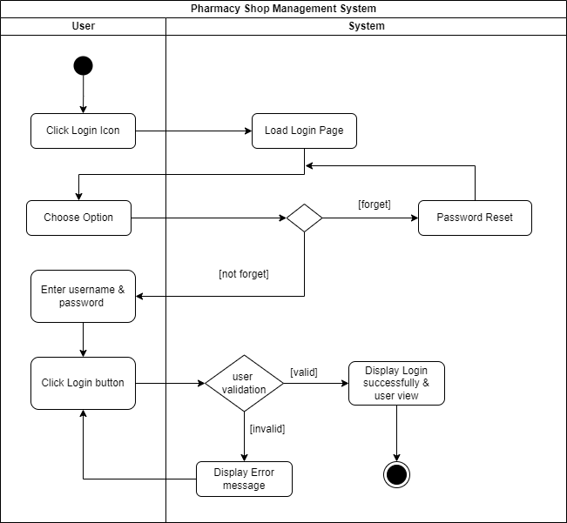

Figure – Log In Activity Diagram

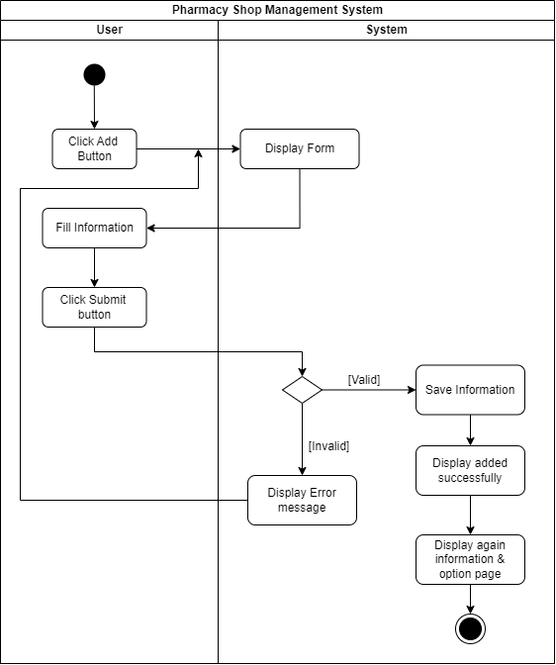

Figure - Add information Activity Diagram

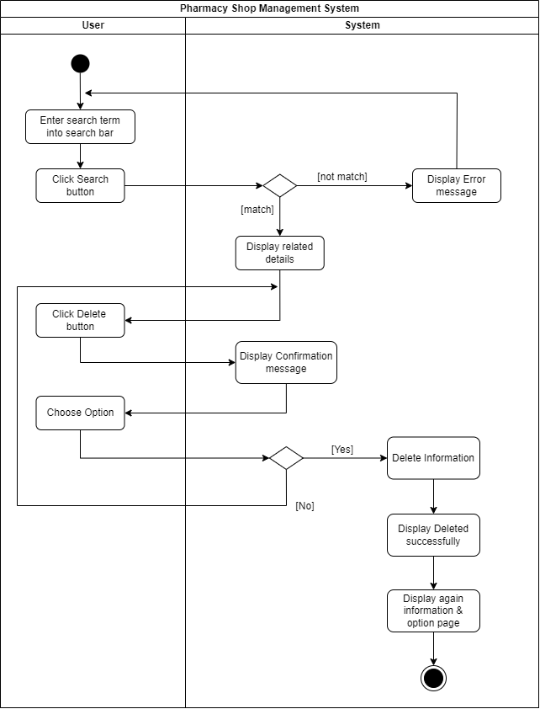

Figure – Delete Information Activity Diagram

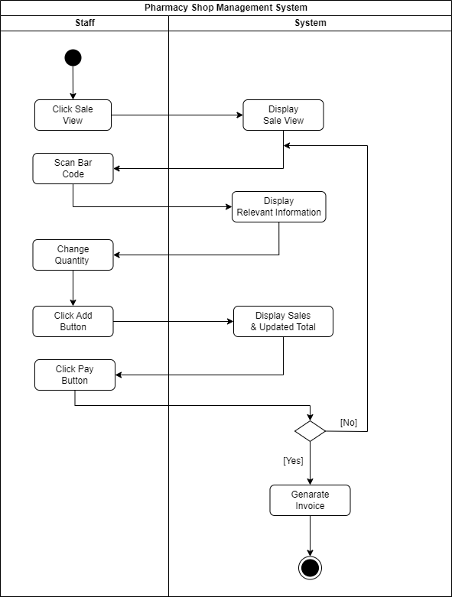

Figure – Direct Customer Management Activity Diagram

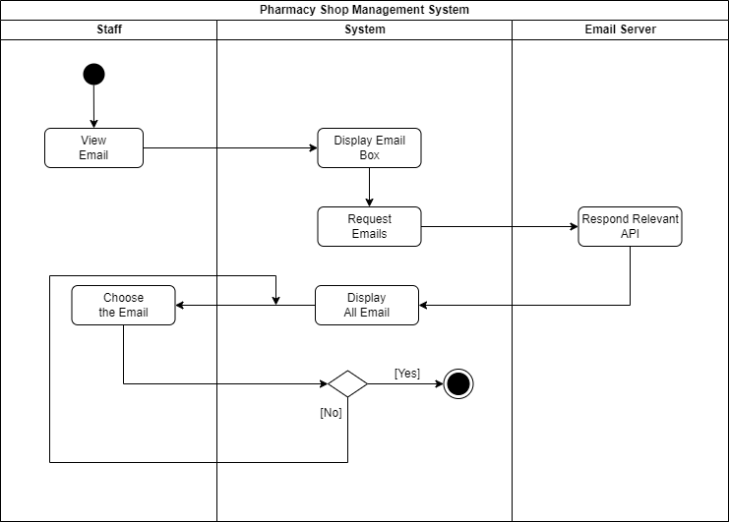

Figure – Formal Communication Activity Diagram

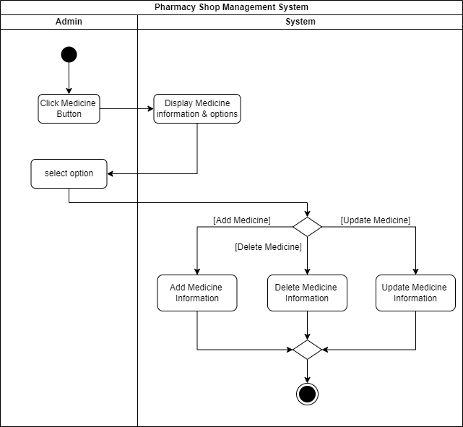

Figure – Medicine Management Activity Diagram

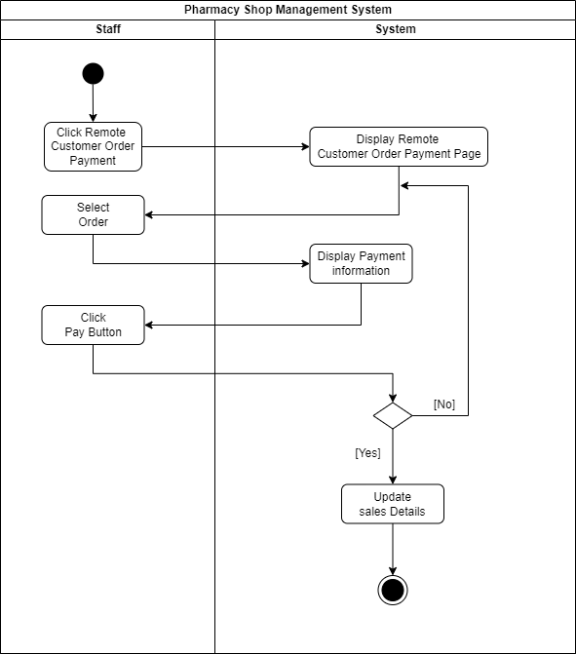

Figure – Remote Payment Activity Diagram

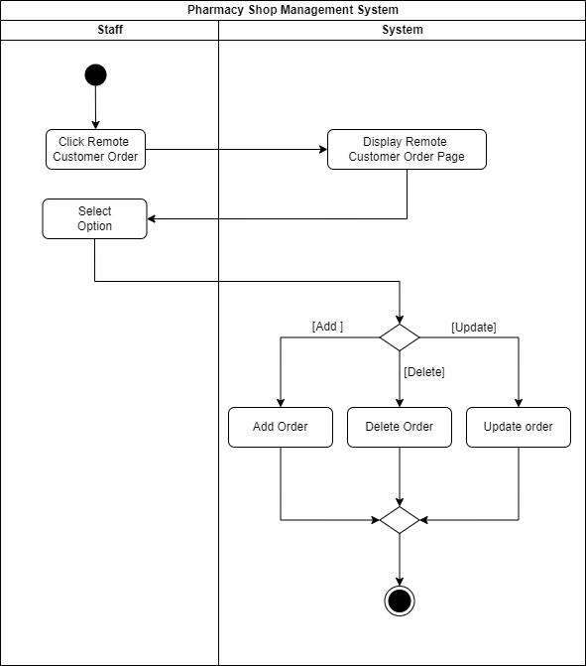

Figure - Remote Order Activity Diagram

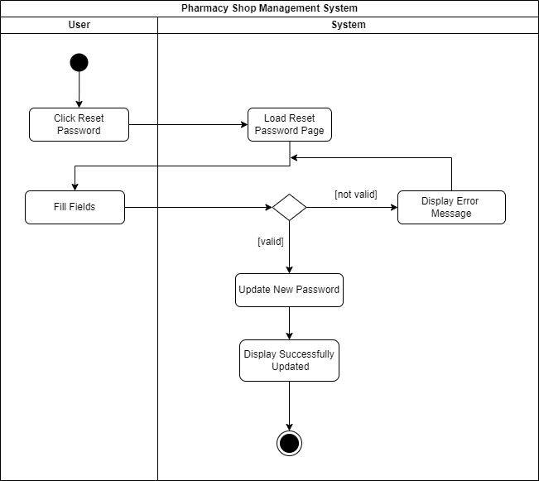

Figure – Reset Password Activity Diagram

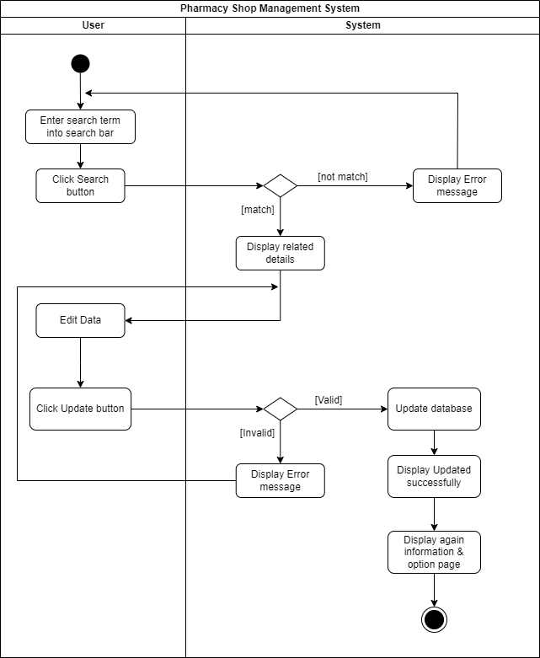

Figure – Update Information Activity Diagram

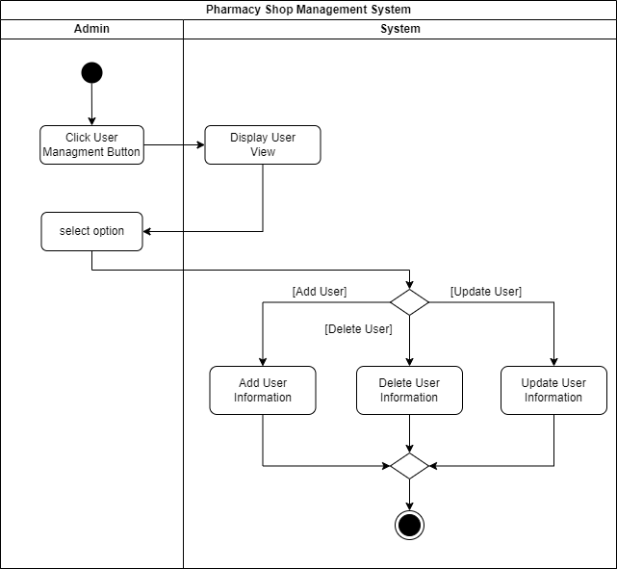

Figure – User Management Activity Diagram

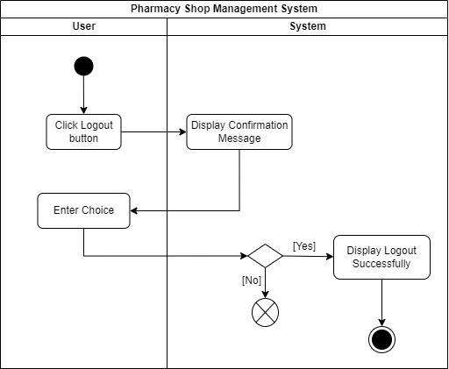

Figure Log Out Activity Diagram

**2.4 Sequence Diagrams**

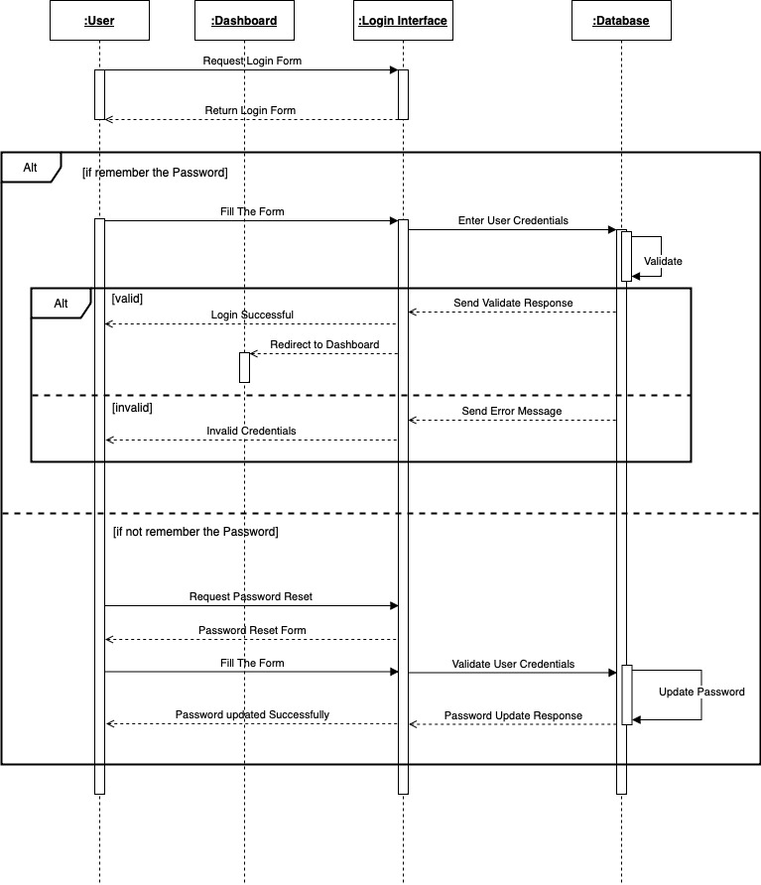

Figure – Log In Sequence Diagram

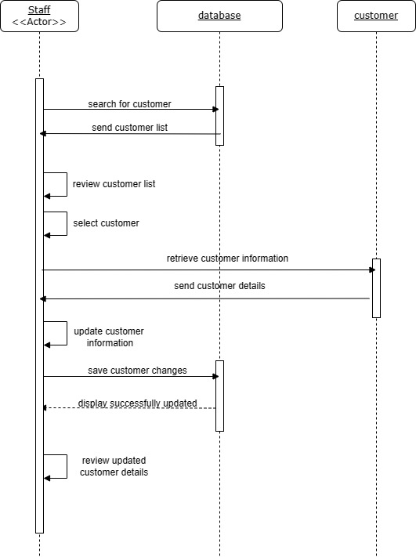

Figure - Manage Customer Sequence Diagram

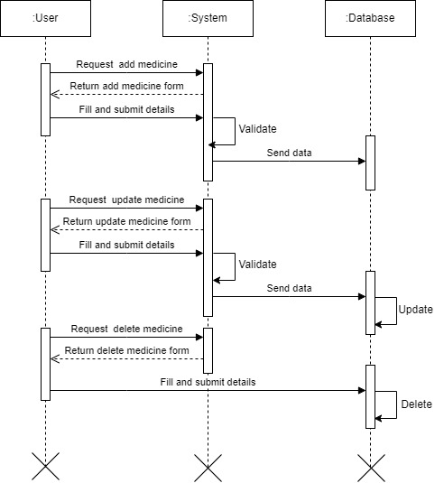

Figure – Medicine Management Sequence Diagram

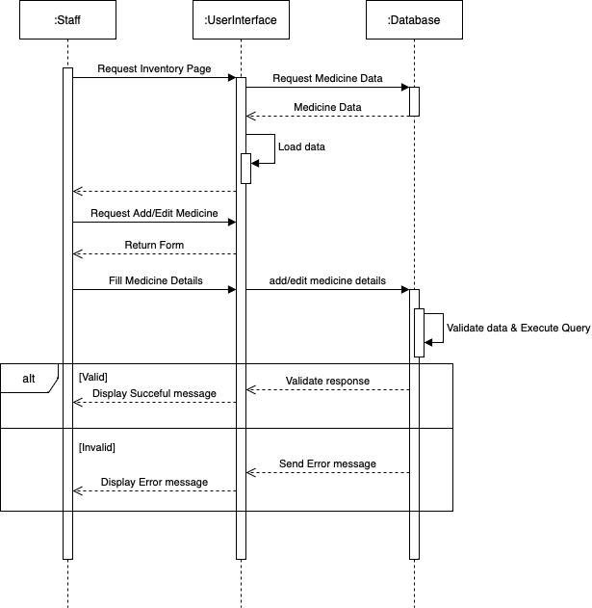

Figure - Inventory Management Sequence Diagram

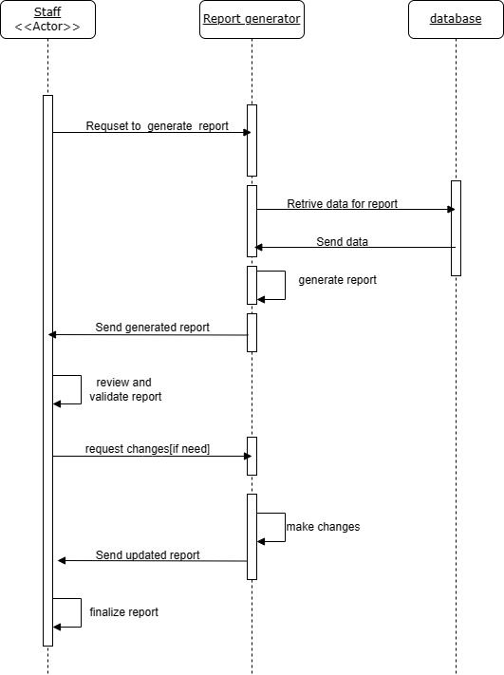

Figure – Report generating Sequence Diagram

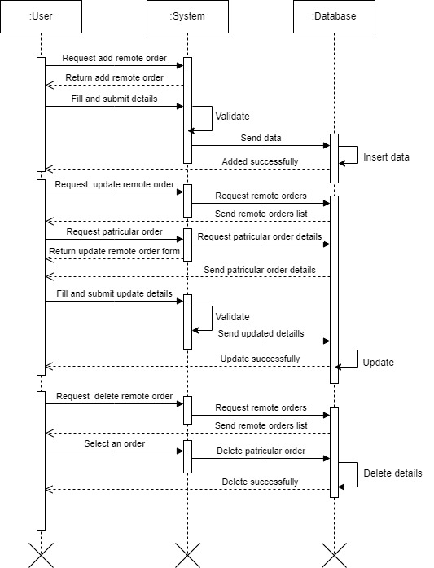

Figure – Remote Order Sequence Diagram

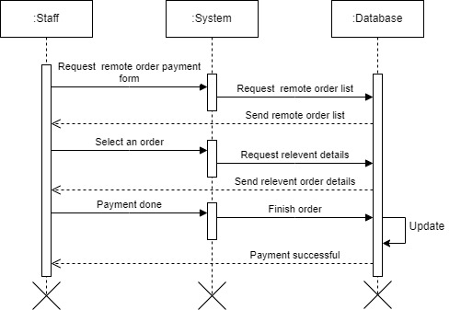

Figure – Remote payment Sequence Diagram

**2.5 ER Diagram**

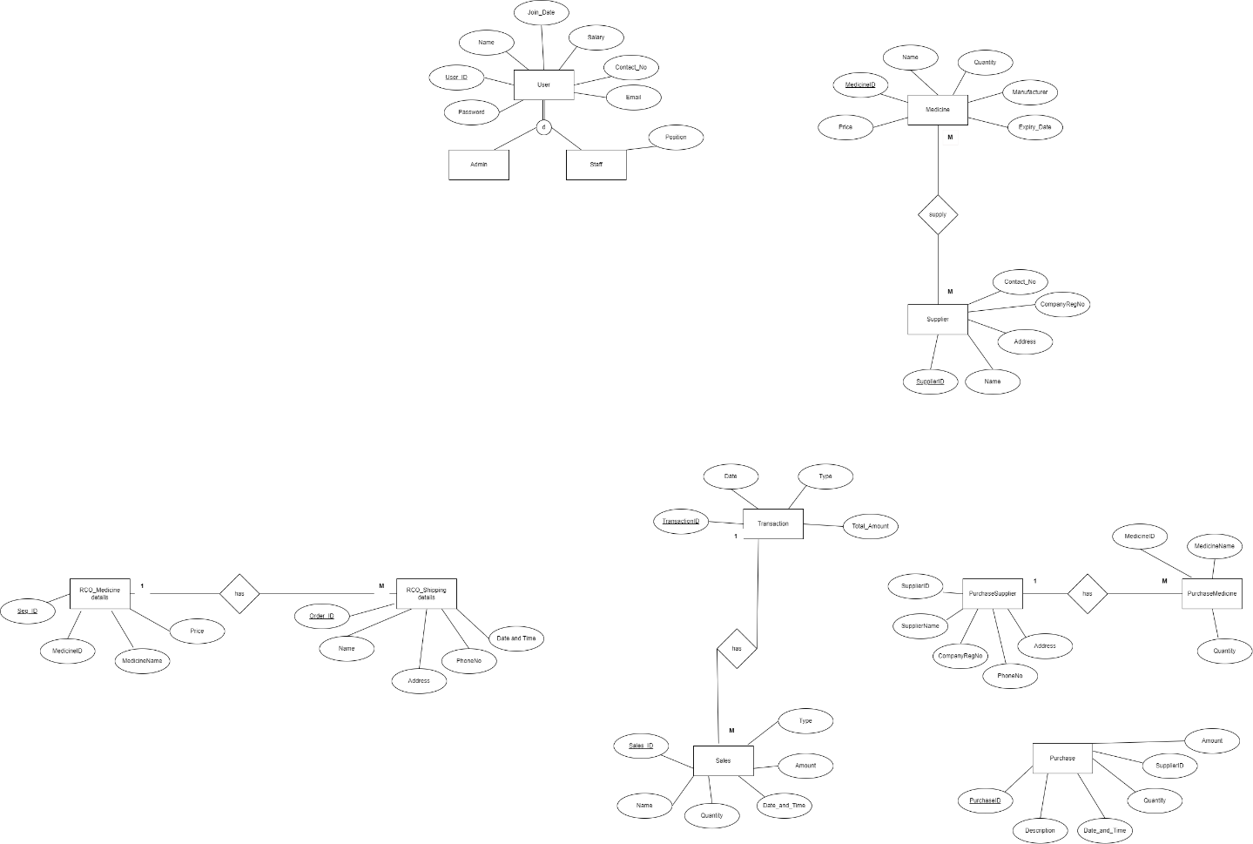

Figure – ER Diagram

**2.6 Software Requirement Specification**

**Functional requirements**

A Functional Requirement is a document that describes the essential technical requirements of a system or feature, including the procedures by which it can be determined that requirements have been met. The following points represent the functional requirements of pharmacy management system.

|  |  |
| --- | --- |
| **ID** | **Description** |
| **Admin** | |
| 1 | Shall be able to log in to the system. |
| 2 | shall be able to create, view, update, delete, customers. |
| 3 | Shall be able to create, view, update, delete staff. |
| 4 | Shall be able to manage user accounts. |
| 5 | Shall be able to generate and manage reports. |
| 6 | Shall be able to add, delete, update, and view medicine. |
| 7 | Shall be able to manage customer orders. |
| 8 | Shall be able to manage payments. |
| 9 | Shall be able to view available medicine stock. |
| **Staff** | |
| 1 | Shall be able to log in to the system. |
| 2 | Shall be able to view customer orders. |
| 3 | Shall be able to manage payments. |
| **Customer** | |
| 1 | Shall be able to log in to the system. |
| 2 | Shall be able to place orders. |
| 3 | Shall be able to make payments. |

**Non-functional requirements**

Non-functional requirements are the requirements that are not directly affect to the system. [1]

* Performance and scalability. How fast does the system return results? How much will this performance change with higher workloads?
* Portability and compatibility. Which hardware, operating systems, and browsers, along with their versions does the software run on? Does it conflict with other applications and processes within these environments?
* Reliability, maintainability, availability. How often does the system experience critical failures? How much time does it take to fix the issue when it arises? And how is user availability time compared to downtime?
* Security. How well are the system and its data protected against attacks?
* Localization. Is the system compatible with local specifics?
* Usability. How easy is it for a customer to use the system?

**Chapter 3: Proposed System Design**

**3.1 Architecture Design**

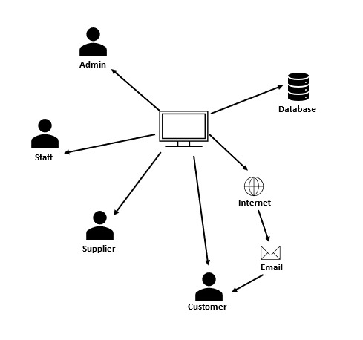

Figure - Architectural Design

**3.2 Proposed System Interfaces**

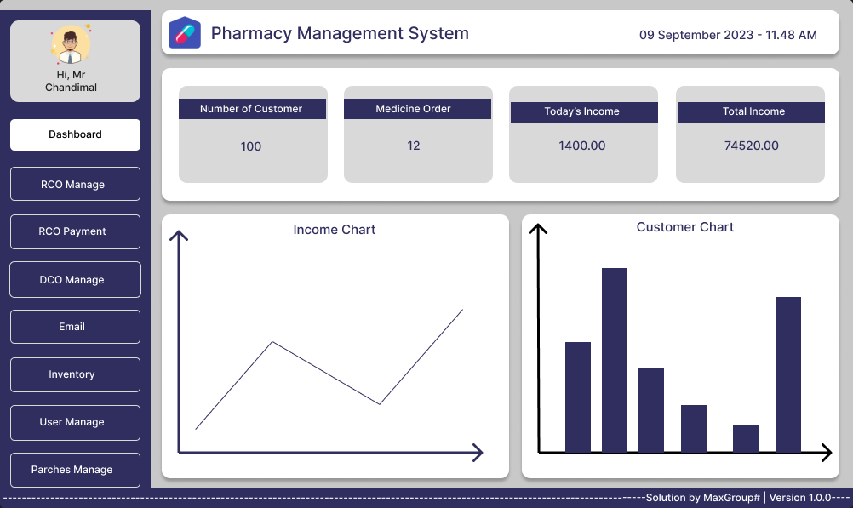

Figure - Dashboard

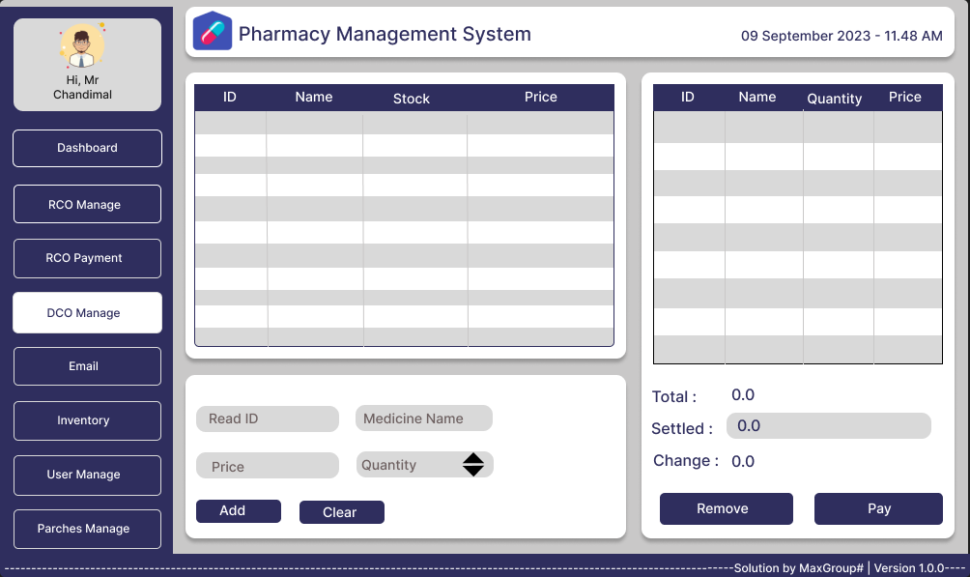

Figure - Direct Customer Order Interface

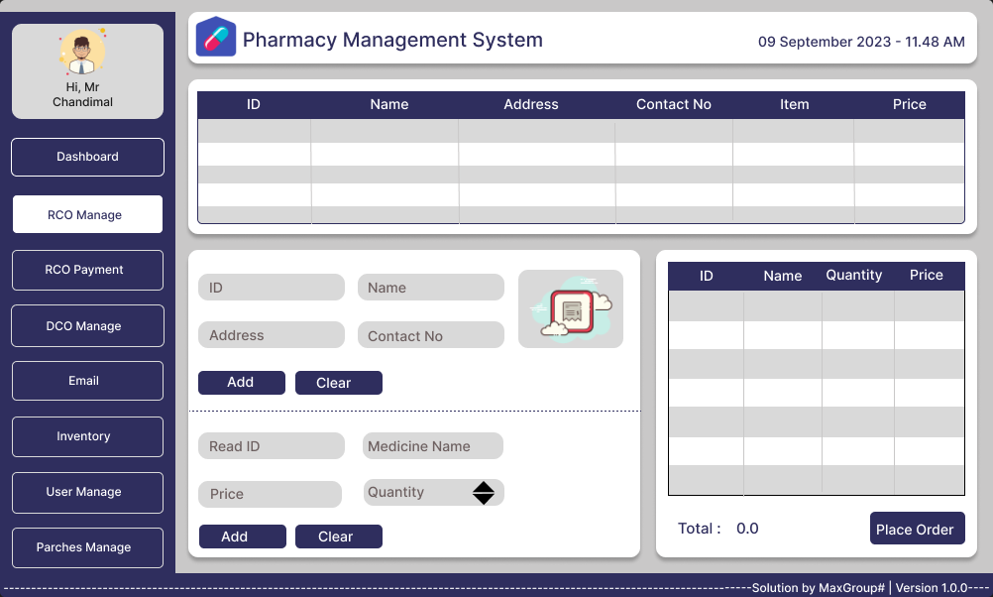

Figure - Remote Customer Order Interface

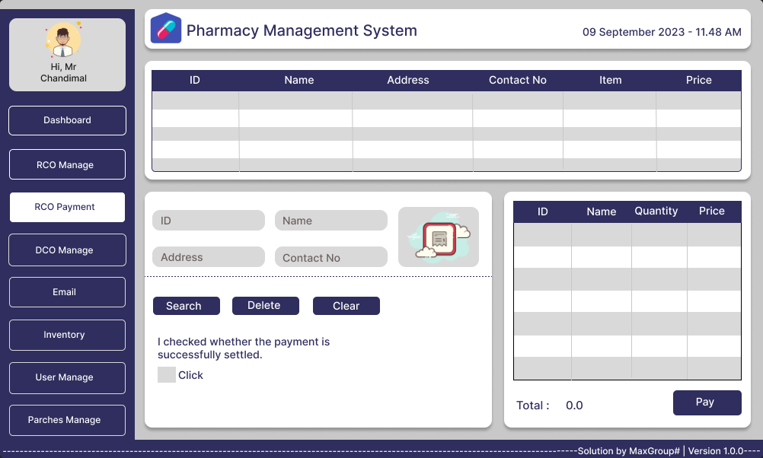

Figure - Remote Customer Payment Interface

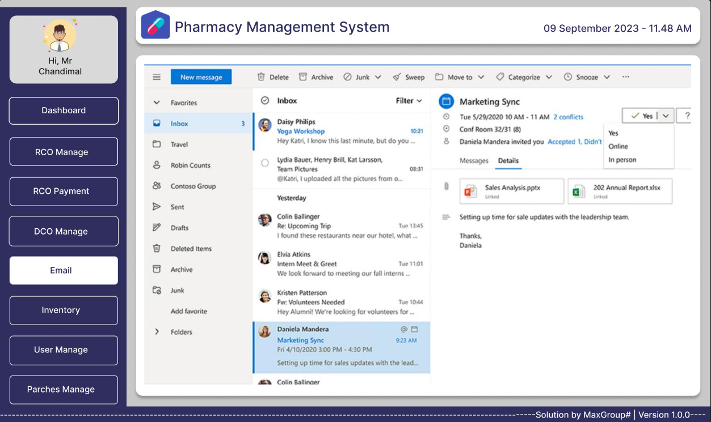

Figure - Email Interface

**3.3 Report Design**

**3.4 Test plan for the system**

**3.5 Proposed Software Engineering Methodologies**

**Conclusion**

**References**

[1] <https://www.altexsoft.com/blog/non-functional-requirements/#:~:text=Non%2Dfunctional%20requirements%20or%20NFRs,reliability%2C%20data%20integrity%2C%20etc>.